**Part I. Modeling**

Raspberry-like metamolecules (RMMs) are synthesized by a wet chemistry method shown in Figure 1. Geometrically, a RMM can be reviewed as randomly putting many small identical spheres (or beads) on top of a big centered sphere (or core). The diameters of the bead and core are *Rbead* and *Rcore*, respectively. All small spheres are closely packed but separated with some unknown distance. All lengths mentioned in this write-up are in nanometer scale, while the scale is omitted for brevity reasons. Keep in mind that one nanometer is 10-9 meter.

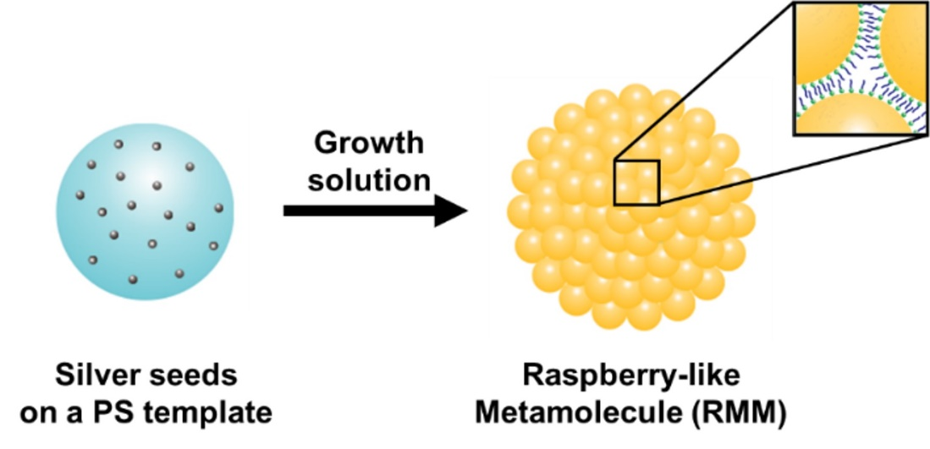

Figure 1. Schematics showing the synthesis of raspberry-like metamolecules (RMMs).

The goal is to investigate the distribution of the intensity of the electromagnetic field inside of the RMM. However, given that the structure is really small, it is quite challenging to experimentally probe these quantities. Thus, we decided to solve this problem via computational modeling.

Due to the randomness of the location of the small spheres, it is impossible to get their exact locations. Therefore, we constructed a model structure using a molecular dynamics (MD) simulation. In the MD simulation, a collection of identical spheres were forced to collapse onto a spherical surface using Euler's method. The force applied to the smalls spheres had three components (Figure 2).

First, an asymmetric harmonic force with an equilibrium position equal to the diameter of the small sphere *2\*Rbead* was applied between the beads. The force between each pair of beads was only applied when the interbead distance was less than the equilibrium distance, creating a purely repulsive force (*F*=-(*x*-2*R*bead)*k*, where *k* is 80 for *x*<2*R*bead, *k*=0 for *x*≥2*R*bead, and *R*bead is the bead radius, *x* is the distance between the center of the two beads).

A second force was applied between the beads and the simulated core. This force was asymmetric and centered on distance equal to sum of the core radius and the bead radius (*F*= -*k*'(*x*-*R*core-*R*bead), where *k*' is 0.5 for *x*≥(*R*core+*R*bead) and 25 for  *x*<(*R*core+*R*bead) and *R*core is the radius of the PS core). The attractive force was set to be fifty times weaker than the repulsive force so that beads were forced to aggregate onto the surface regardless of the forces excerted by the beads above them. Here the harmonic forces are described relative to the axis connecting the objects.

A third weak damping force proportional to the velocity (*F*= - *ɤV*, where *ɤ* is a positive damping constant) was applied to the beads in order to force the system to converge.

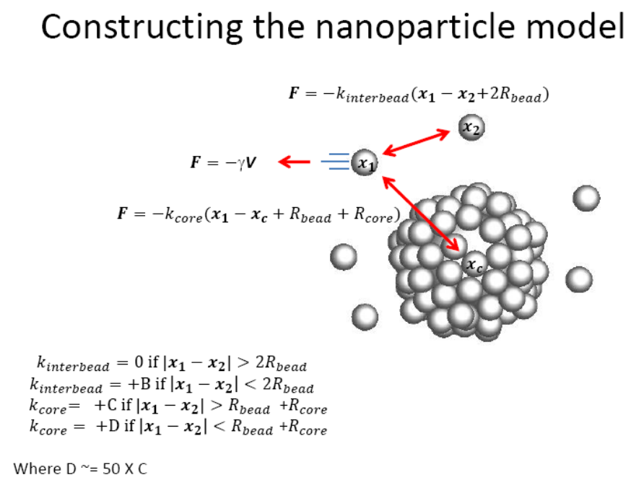

Figure 2. Schematics showing the construction of the nanoparticle model.

Here the number of beads, size of the beads and cores, and the separation between beads are scanned and optimized to make the simulated overall electromagnetic extinction consistent with experimental results.

**Part II. Data Analysis and Visualization**

The above models are fed into a commercial software to calculate the electromagnetic intensity by solving differential equations. The simulated results are analyzed and visualized using MATLAB. Please refer to the published articles for details.



Figure 3. Distribution of the bead-to-bead distance.

Figure 4_Aug2015.tif

Figure 4. Electromagnetic intensity distribution of the cross section of individual RMM and RMM dimers.